**EXPLORIN ACADEMY**

**Trends in Startups**

**PROBLEM :- *To analyze a database of startup company using SQL queries , exploring various metrics to understand trends in the startup ecosystem.***

**DATABASE:-** TrendsInStartups_Explorin.csv

1. Calculate the total number of companies in the dataset.

select count(*) as total_company

from TrendsInStartups_Explorin



1. Determine the total value of all companies in the dataset.

SELECT SUM(VALUATION) FROM "TrendsInStartups_Explorin"

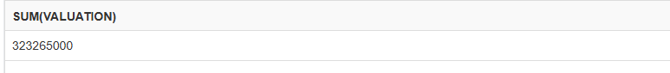

1. Find the highest amount raised by a startup at the 'Seed' stage.

SELECT ID, NAME , valuation FROM "TrendsInStartups_Explorin"

ORDER BY VALUATION DESC LIMIT 5

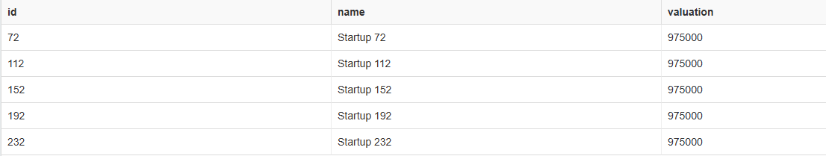

1. Identify the year when the oldest company on the list was founded.

SELECT MIN(founded_year) as oldest_company_founded

FROM "TrendsInStartups_Explorin"

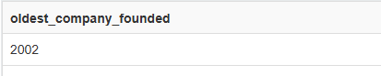

1. Calculate the average valuation within each startup category.

SELECT SECTOR,AVG(VALUATION) AS AVG_VALUATION

FROM "TrendsInStartups_Explorin"

GROUP BY SECTOR

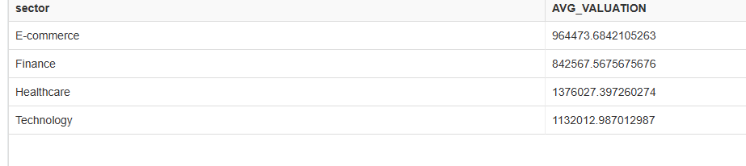

1. Determine the top locations with the highest number of startups.

SELECT LOCATION, COUNT( LOCATION ) AS NUM_STARTSUP

FROM "TrendsInStartups_Explorin"

GROUP BY LOCATION

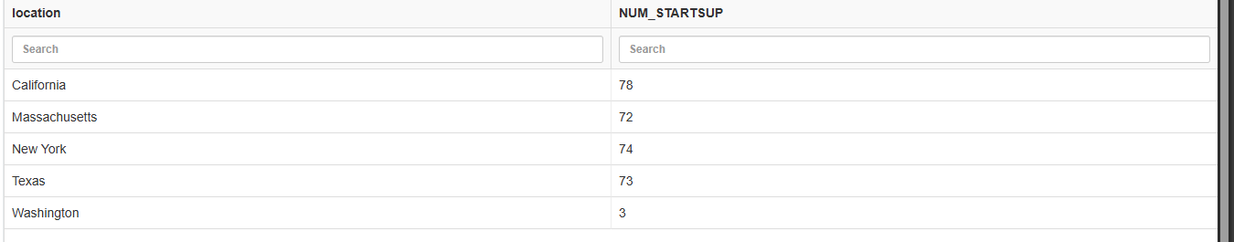

7. Calculate the average size of startups in each location where the average size

exceeds 500.

SELECT DISTINCT location,avg(size) avg_size from "TrendsInStartups_Explorin"

WHERE SIZE>500

group by location

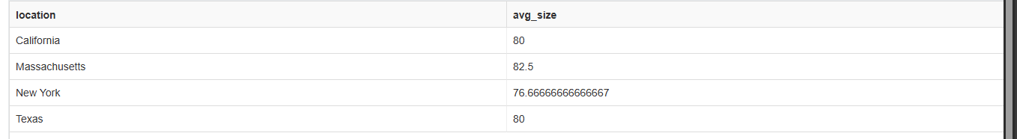

8.Find the top 5% of startups with the highest valuations.

SELECT COUNT(ID) from "TrendsInStartups_Explorin"

ORDER BY VALUATION DESC LIMIT 15

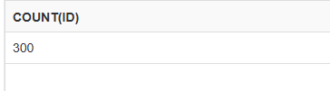

9. Identify startups that have raised funding in every stage (Seed, Series A, Series B, etc.)

SELECT name , count(stage) as A FROM "TrendsInStartups_Explorin" group by name having A=4

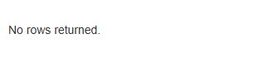

10. Calculate the percentage growth in valuation from Seed stage to Series A for each startup.

SELECT s1.name, ((max(s1.valuation) - min(s2.valuation)) * 100.0 / min(s2.valuation)) as growth_percentage

from "TrendsInStartups_Explorin" as s1

join "TrendsInStartups_Explorin"as s2 on s1.name=s2.name

where s1.stage = 'Seed' and s2.stage = 'Series A' group by s1.name

